
The blue and yellow represent Legacy Pointe's colors, and the green (growing higher) represents the continuing growth provided by our residents.
By Jonathan Wahl

July 2024

Our Day Begins – Here Comes the Sun



Photos by Vicki Tindall


Photo by Jonathan Wahl

OUR FEATURE EVENTS

The Employee Scholarship Awards

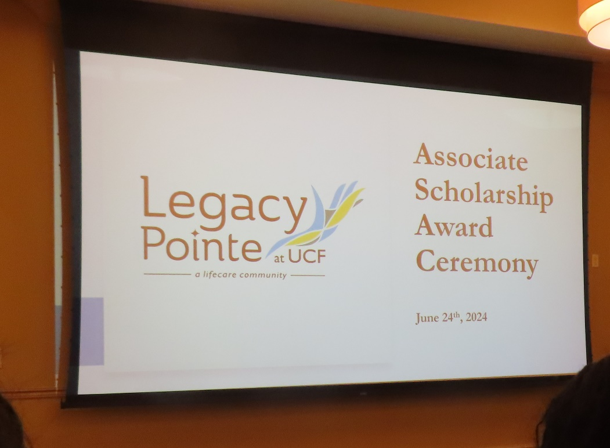

Employees receiving L.P. scholarship awards

19 total scholarships were awarded to employees. Over $27,000 was raised for the scholarship fund.

The event was very well attended, and all the awardees gave a heartfelt speech about how much receiving this scholarship meant to them and what it could do for their education.

Jose Centeno, of Human Services, has more information on the awardees and what each recipient was going to school for.

And the Scholarship winners are

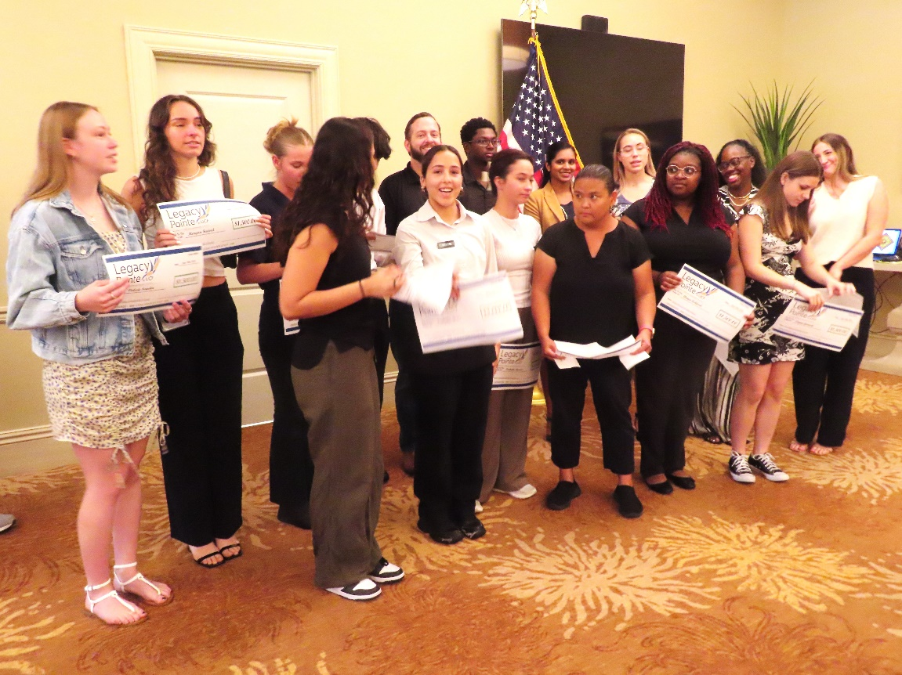

Here are the names of the recipients

Braylynn Hawes, Danaikea Jean, Aniya Ashford, Leyna Gorniak, Morgan Fadoul, Isabella Ruiz, Sofia Llerandi, Elizabeth Kocks, Fanny Ravelo, Haidie Samson, Stacy Ramkissoon, Brianna Wallis, Andres Calderon, Christopher Branum, Isabella Barrios, Sofia Bustamente, Valerie Sowden, Kelli Dawson, Malachi LaRue.

Is this the GHOST of Legacy Pointe



The picture was taken at 6 AM by Dona Hams
Ask her what it is

Memorial Day Recap at Legacy Pointe

Photo and Video by Jonathan Wahl

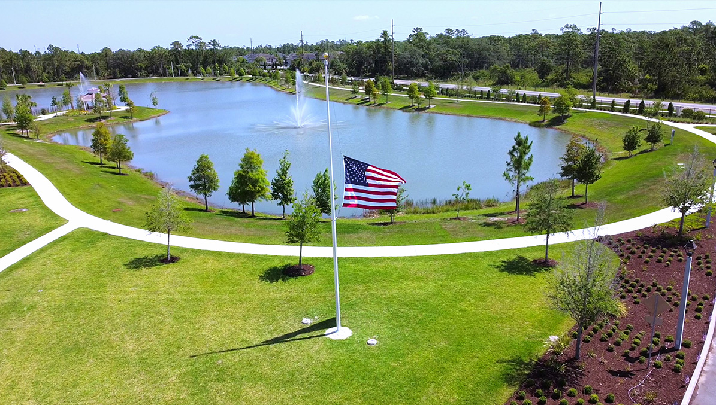

This photo and the link to the Veterans Memorial Day Weekend were submitted to the L.P. Independ Times by Jonathan Wahl

Below are Jonathan’s instructions to view the events.

For those who were unable to attend, or would like to remember:

The 2024 Memorial Day Weekend events (The 24 May Missing Man Table, and the 27 May Memorial Day Ceremony) are now available on video and can be viewed online at:
Scroll down to view the videos. No sign-in is required.

https://lpresidentsonline.org/LPMMD2024/MM2024.html

The Flagpole Dedication on 24 May was not videotaped.



Photos by Vicki Tindall

(Note Regarding the Memorial Day Ceremony: Unfortunately, our videographer failed to tape the entire event. Significant portions were not captured. I obtained the raw video footage and produced a video containing as much of the event as possible).

Ping Pong Comes to Legacy Pointe

Monday, June 10th was a resident vs. employee ping pong game starting at 2:00pm.

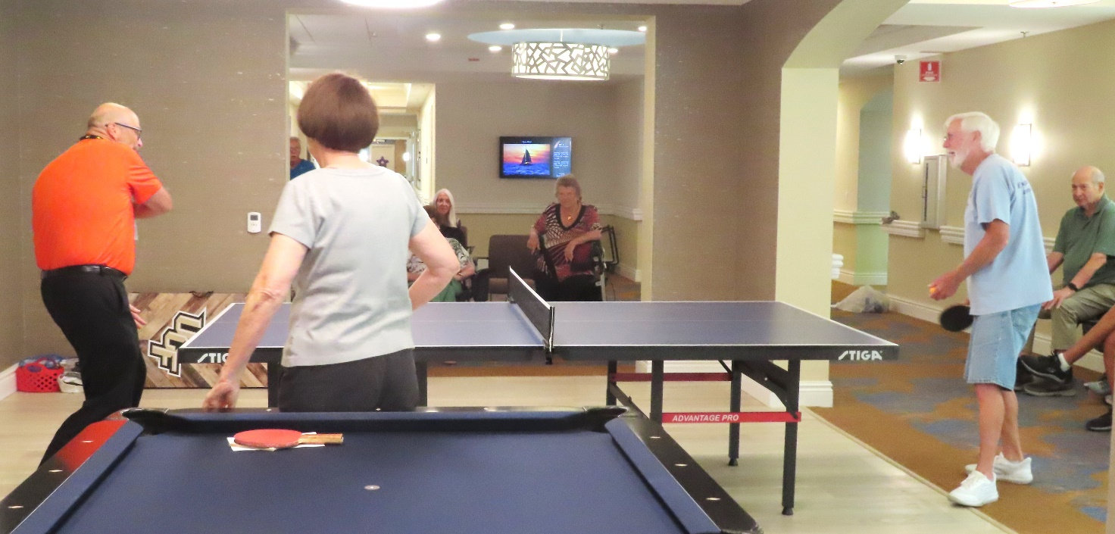

Did David win the point with a vicious backhand

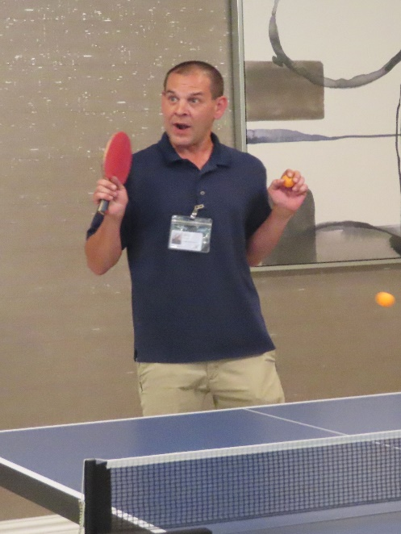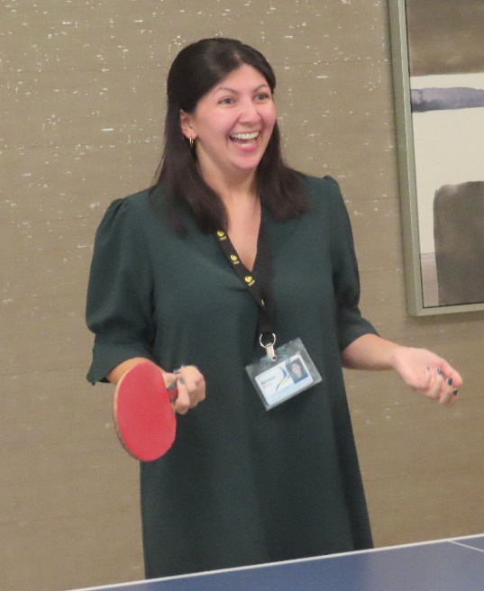

The Staff looked surprised – did they hit the ball?

This is a fun way for us to use the ping pong table and show off our new game room. And if you cannot play at least you can watch.

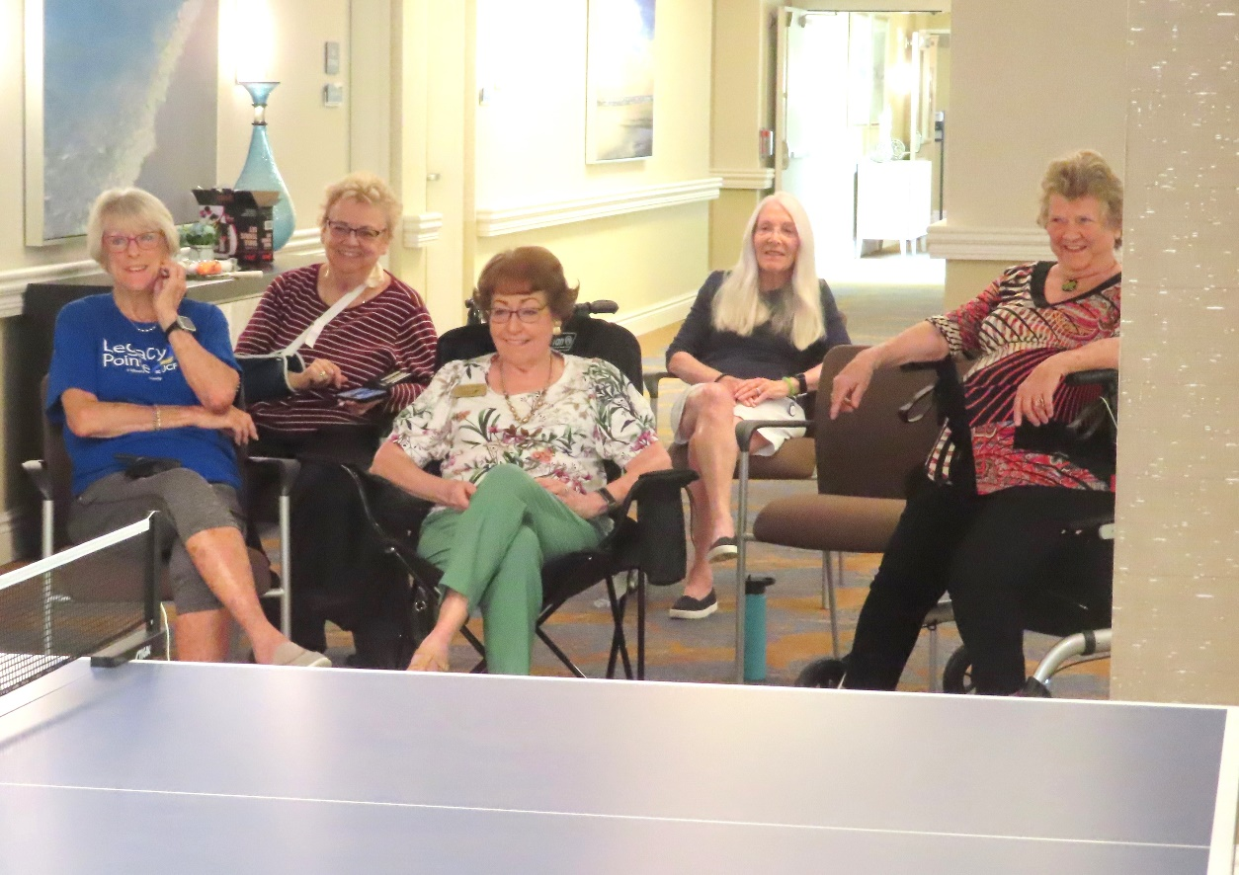.
Photos by Vicki Tindall
Where is the game room you might ask? In between assisted living and memory support right before you get to the gift shop. You can't miss it! Please sign up for the ping pong game in the activity binder.

EARTH DAY IS REALLY 365 DAYS – Our Monthly Reminder

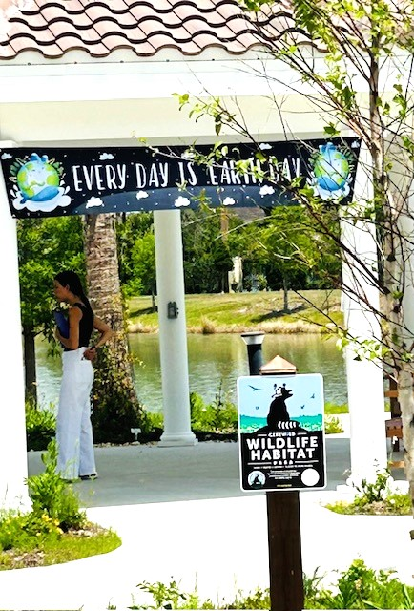

Photo By Maureen Reed

So, to keep Earth Day alive throughout 2024, the Legacy Pointe Independent Times will bring you monthly reminders about what you can do to make our planet bright blue and our air free from pollutants.

The Theme for Earth Day 2024 is “Planet vs. Plastics”.

This month as promised the LP Independent Times will continue the industry’s charade on our burden to clean up their mess. This time a key corporate lawyer has issued a dire warning to the companies involved in the production of plastic.

Our Editorial for the Month of July

The Chemical Companies have been caught! Now What?

The New York Times had this warning in a story written by Hiroko Tabuchi

Lawyers to Plastics Makers: Prepare for ‘Astronomical’ PFAS Lawsuits

Brian Gross of the law firm MG+M warned the chemical companies that there are scores of litigations coming that will “Dwarf anything related to the asbestos” lawsuits. The initial lawsuits have been brought by numerous cities and states that are trying to clean up plastic residue from their drinking water. The residue is from the PFAS chemical compounds that cannot be broken down and end up as micro and nano plastic particles in everything, for example in our food, landfills, drinking water, etc.
“Last year, 3M agreed to pay $10 billion to water utilities across the United States to pay for clean-up to those municipalities who has requested it”.
PFAS were first synthesized by DuPont in the 1940s. This synthesization led to the development of Teflon pans by DuPont and 3 M’s Scotchgard fabric protector.
Who knew What
As early as 1961 manufacturers knew of adverse health effects due to PFAS chemical compounds. But not too much scientific study was conducted until DuPont was fined $10 million in 2005 because they knew the dangers of PFAS but failed to warn the public.
One attorney, Emily Lamond, from the Law Firm Cole Schotz, which specializes in these cases said “Take tobacco, asbestos, MTBE, combine them and I still think that we are going to see much more PFAS litigation.
Scientific research is still in its infancy on these chemicals. But wait and see these fined will mount ups and will be in the hundreds of billions of dollars.

What should we do?
The worst thing is to just sit around and wait. Act now. Stop buying water in plastic bottles, stop using single use plastic everything from shopping bags to plastic wrap, stop storing food in plastic containers.
Plastic has already leeched into our bodies. Protect yourself while there is still time.

Next month what technology is doing to change how we clean up the industry’s plastic mess.

It’s Springtime and Who are These Two in the Villas?



Mom said we are supposed to hide Is this hiding enough
Photos by Fred Jackson

Pickleball Courts Are Coming Soon!
by Graham Ricks

We are thrilled to announce that our community will soon be home to new pickleball courts! This exciting development is set to enhance our recreational facilities and provide a fantastic venue for both seasoned players and newcomers to the sport. Here are two questions we have been asked.

When Will the Courts Be Finished?
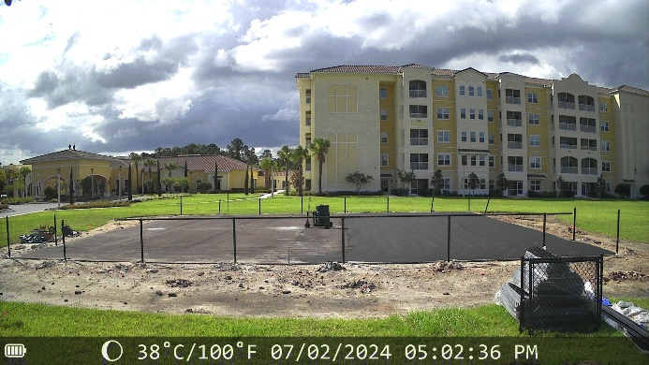
Construction on the pickleball courts began in May 2024. The area was cleared of sod and sprinkler lines to make way for the courts. To prevent flooding, dirt and limerock were trucked in and compacted with a 5-ton vibratory roller. The area was then paved with 1.5" thick asphalt, which was allowed to cure for four weeks.
Currently, two important steps are underway:
- A 4-foot-high fence is being installed around the perimeter, with entrance gates on both the east and west sides.
- An acrylic resurfacer is being applied to the asphalt to correct any imperfections in the surface.
Before the courts can receive their final coats of paint, sidewalks must be installed up to the court surface. Josh Gorniak is working to select a contractor for the sidewalk installation. Once the sidewalks are in place, the courts will receive two coats of sand-filled acrylic, the nets will be installed, and the cleared area around the courts will be landscaped to make the grounds attractive.
We are hopeful that the courts will be complete this month. Get ready to enjoy some exciting pickleball action soon!
Will Lessons Be Offered for New Players?
Absolutely! Once the courts are available for use, pickleball lessons will be offered to Legacy Pointe residents. There will be different levels of classes to cater to all skill levels:
- Beginning Classes: These classes are designed for people who have never played the sport. They will focus on court safety, being prepared, basic game rules, scoring, and player positions. We have extra paddles to loan to beginners.

- Intermediate Classes: These classes will delve deeper into the official rules, game strategy, and more advanced techniques.

Our experienced players will be there to guide you every step of the way, ensuring that you have a fun and rewarding experience learning pickleball. Stay tuned for more details on the exact dates and times for these lessons.
We are glad to see our community come together to enjoy this fun and engaging sport. Whether you are a seasoned player or a complete beginner, the new pickleball courts will provide a fantastic space for everyone to play, learn, and connect. Get ready to join us on the courts soon!

Pickleball is more than just a sport. It’s about staying active, making friends, and challenging yourself both physically and mentally. It’s a game that brings people together and creates lifelong memories.

Thank you for the Butterfly Garden
Pictures and story by Mary Catherine Ricks



This article is a special thank you for all the time and energy Legacy Pointe residents have donated to this beautiful enhancement of our community. We offer a special thank you to Kathryn and Tony Mennella and Kathryn’s sister Karolyn Enchasi for their knowledge and leadership in this gift from their hearts.

The collage of pictures inspired me to find out more about butterflies. Here are some interesting facts:


Butterflies typically only live for 2-4 weeks and the smallest ones only a few days. Monarchs and Mourning Cloaks are the exception and can survive for as long as 9 months.

It has been determined that butterflies can see up to 10-12 feet. They do not see all the colors we see but they do see ultraviolet colors that we do not see! In fact, it is thought that they may even have ultraviolet marking on their wings to help them identify each other including a possible mate.

These insects are most comfortable in temperatures of 82 to 100 degrees Fahrenheit. On cooler days they must bask in the sun or shiver to warm up their flight muscles.

When adults begin to emerge from their chrysalis, the proboscis (mouthpiece) is in two pieces and to survive, they must assemble it quickly to be able to drink their liquid only meals.

Trip to Sanford for Cruise on St. John’s Riverboat







Dolores Rutledge
Gave the Granddaughter of Sandy North a Harp Lesson

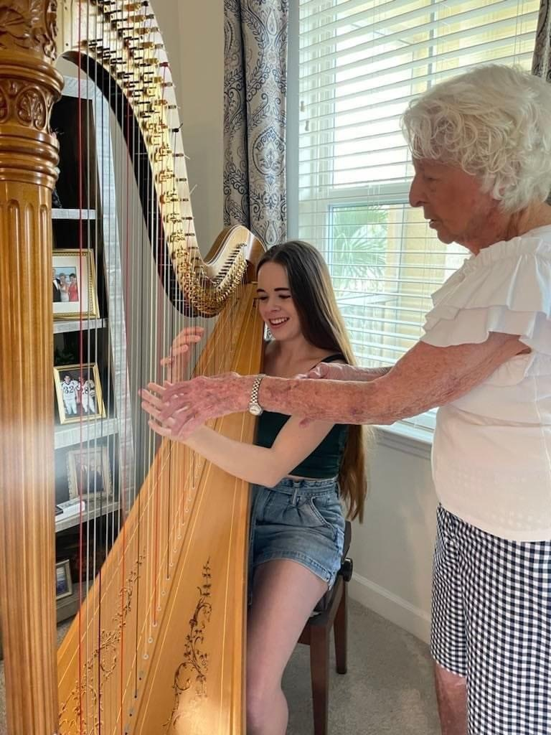

Sandy North writes a little story about how her granddaughter met Dolores Rutledge.

My Texas granddaughter, Katie North, has been taking viola lessons for many years. She now is a sophomore music major (with a minor in physics) at Baylor University, and plays in the Baylor Symphany Orchestra.

On a recent visit to LP— we invited some neighbors in to hear her play. Delores was here and heard her play. She invited Katie to her apt to see her harp, and hence — the harp lesson happened! — a wonderful experience for Katie!

A Little bit of the History of Legacy Pointe
Were you in this picture in the Spring of 2021? If so, you remember meeting for lunch at the Celeste Hotel. Legacy Pointe was offering us a ‘gourmet lunch’.

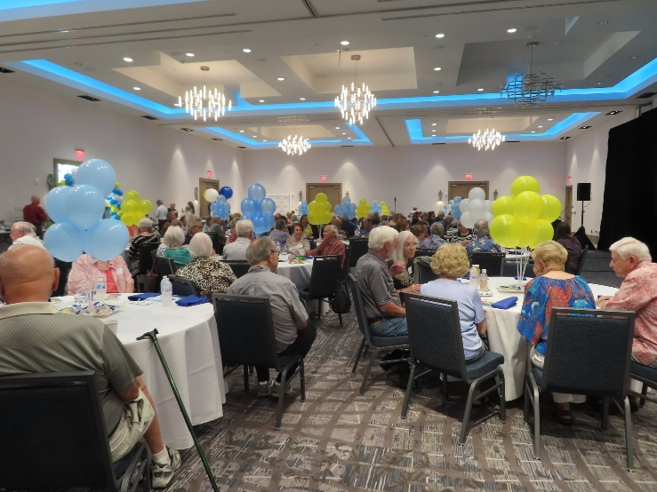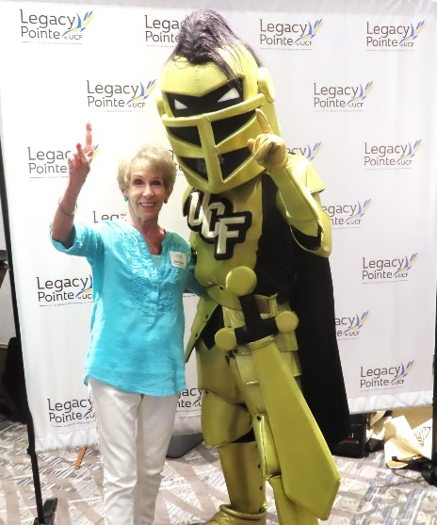
Luncheon at the Celeste Hotel Guess who stopped by

It was a special event because after lunch we were all going back to our cars. We were heading to the construction site of our future home at Legacy Pointe. The purpose of the car caravan was so that we could each sign one of the roof rafters which would be used in the construction of L.P.


Photos by Vicki Tindall

It rained most of the afternoon, but it stopped long enough to allow us to sign our names.

Recycling by Mitch Mitchell

This is your July update on existing recycling programs and new initiatives that are getting underway. A HUGE thank you to all of you who are recycling away and to those who are doing the work to make it happen!
On August 1st Legacy Pointe will put a new "official" recycling effort into place. We will update how this program may affect the recycling programs currently underway as we get more information. For the most part, it is likely to increase the number of products being recycled above and beyond the current efforts. At present it currently appears from information received that the cost of this additional service may be relatively minimal on a monthly basis; however, if there should be substantial additional costs incurred for these services, we as a community will need to examine the cost vs. benefit of these additional services.
1. Aluminum cans. Recycling of aluminum cans continues at a vigorous pace! Thus far the IL 3rd Floor aluminum canning factory continues to produce cans at a near-alarming rate and is the undeniable IL championship floor! Production there remains highly focused on Coke products and an unknown variety of root beer (no...NOT Budweiser!).
(NOTICE: Only aluminum cans can be recycled — no pet food cans, pie plates, aluminum foil, etc.)

POC: The Can Dancers & Katherine M. (our stealth Kan Kollector)

2. Large plastic meal containers. The black/clear covered meal boxes that come out of the kitchen are being recycled in large numbers and are going to Hope Helps here in Oviedo. Some of the containers are being used by their food pantry; the remainder are being sold (quickly!) out of their store. As of mid June, 1275 of them have been recycled in this manner. We recycle and Hope Helps receives charitable contributions. These plastic meal containers can be placed in the bottom left cabinet in the unit outside the gym.
NOTICE: Meal containers that are cut into separate top and bottom pieces cannot be recycled to Hope Helps and can only be sent out as recycled plastic. We are leaving some of these severed boxes in the cabinet if you would like to use already cut containers and save intact ones for Charity use.
POC: Mitch & Sal

3. Re-Use Copy Paper. Renata and our wonderful dining room staff are making the effort to collect dated menu pages from both the Main Dining Room and the Assisted Living Dining Room. Much of this copy paper is in excellent condition for re-use for one-sided “junk” printing. Many of us print items for temporary or non record copy uses – or for committee use – and this copy paper is perfect for this. MAKE USE OF THIS RESOURCE AND SAVE THE “GOOD STUFF” FOR WHEN IT’S REALLY NEEDED! This paper can be found in a basket located on the bottom shelf in the cubby unit for the villas—located in the small ante room that leads into the auditorium (just off the main rotunda).
POC: Mitch (looking for a volunteer!!)

4. Old eyeglasses, eyeglass frames, lenses and eyeglass cases. Don’t just discard any of these! The Lions Club has an EXTENSIVE program to recycle these in many ways. All of these components can be placed in the two Lions Club boxes located on a shelf in the cubby unit for the Villas.
POC: Les Tandler

5. Hearing aids. Just like the eyeglasses, the Lions Club has a companion program to use unneeded hearing aids for the needy. Hearing aids can be placed in the same containers used for eyeglasses.
POC: Les Tandler

6. Batteries. Although all the Media attention is on Lithium and Alkaline batteries, all batteries, including those in your phone, watches, tools,.etc., contain some form of metal which then corrodes and leeches into the environment. You can drop your batteries off here in Legacy Pointe in the top right drawer in the cabinet next to the door into the IL exercise room (gym).
POC: Joe Solymossy

7. Printer cartridges. DO NOT THROW YOUR USED PRINTER CARTRIDGES AWAY! These cartridges are now being recycled through Staples and the proceeds are being used to supply cartridges and other print supplies to Forward Paths Inc. in Leesburg, FL. Forward Paths works with the young adults who age-out of foster care at 18 years old, and usually end up out on the streets. Please place any printer cartridges you are getting rid of in the same drawer the used batteries are collected in. Joe Solymossy takes the cartridges to Staples for Forward Paths.
POC: Joe Solymossy

8. Electronics. Cell phones, iPads, iPods, MP3 players, DVD players, flat screen TV or computer screens, laptops, etc. SHOULD NEVER be put into the normal trash. Today you can take the portable electronic items to Best Buy or to Staples. If you have a Staples Rewards account (free to set up) you can get $5.00 per one returned item each month and the points do not expire. As an alternative, Forward Paths, Inc has a rewards account and Joe does recycle small electronics under their account. If interested, talk to Joe.
POC: Joe Solymossy

9. Newspapers/paper. We witness a huge waste of paper here. Many people are taking their paper to recycle at Publix stores or at the Oviedo recycling point in the City Hall area. For the time being please place your newspaper material with the cardboard in the trash rooms.
POC: Volunteer needed! We need YOU!!!

10. Plastic/plastic bottles. A continuing issue. There is almost no market for recycled plastics, while at the same time plastic trash poses some of the most severe long-term risk to the environment and danger to living life forms (that includes us!!). At this point a few of us who discover items marked as noted below pick them up out of the trash rooms if convenient for us. Residents can drop them at the Oviedo recycling point or at Publix stores.
NOTICE: Plastic items (bottles, containers, some toothpaste tubes, Legacy Pointe meal containers, etc.) with the number “1, 2 or 5” in the recycling symbol on the bottom of the container and plastic bags can be recycled. The vexing part is that most other plastics are not currently recycled and go to land fill.
11. Glass bottles/containers. Currently there is not much of a call for glass bottles. At least when these items go into the ground no harm is done and, in fact, they give future generations a reason to dig in the ground for “artifacts!”
As a final note. All of these efforts have arisen on the basis of resident thoughts and suggestions so that we can do our small part to save and recycle resources and, in some minor way AID OUR AILING PLANET. These programs are largely autonomous in nature—not interlinked with others. Some of these projects already have champions who are taking them in hand. Some others still don’t. I will be looking to find able stewards for those that don’t, as well as a “Recycling Czar” to act as an overall spokesperson and “pen pal” for these efforts.
On behalf of all those working on our Legacy Pointe recycling efforts. Mitch 

It’s Springtime and Guess Who is Here?
It’s the Sandhill Crane Family


Photos by Vicki Tindall

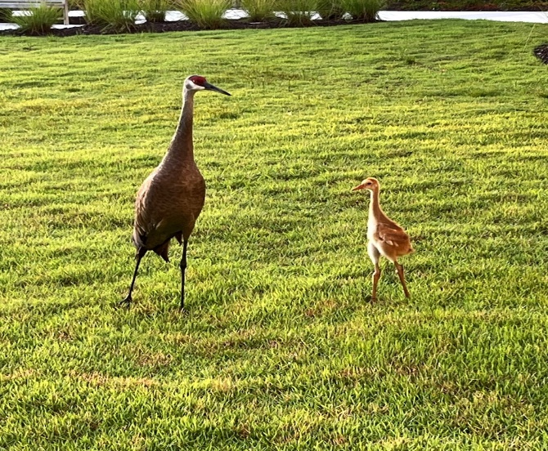
It is a safe place to be in the middle I wonder what they are saying
Photo by Jonathan Wahl Photo by Dona Hans

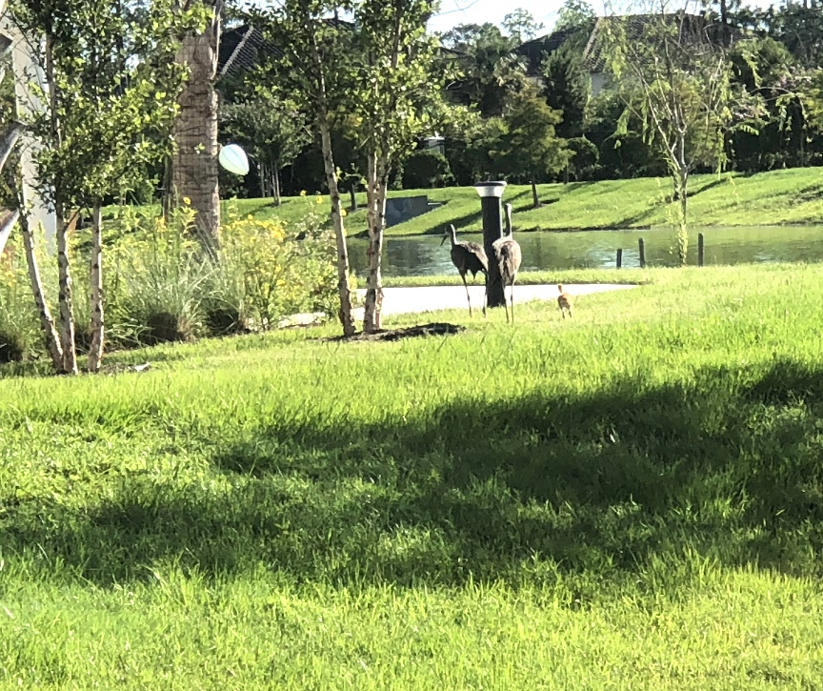
I can hardly keep up! Don’t they realize they have longer legs!
Photo by Marsha Call

And We Have Another Visitor


Blue Heron by Laurel Browning

Another Musical Treat

The Legacy Pointe Choral Group aka the Legacy Pointe Singers presented another concert on Friday July 5th at 7 PM in the auditorium. The concert featured a full program of patriotic music. Many of the pieces are well known and led to many ‘sing-a-longs’ throughout the evening.

Thank you to Sue Brown and the Group.

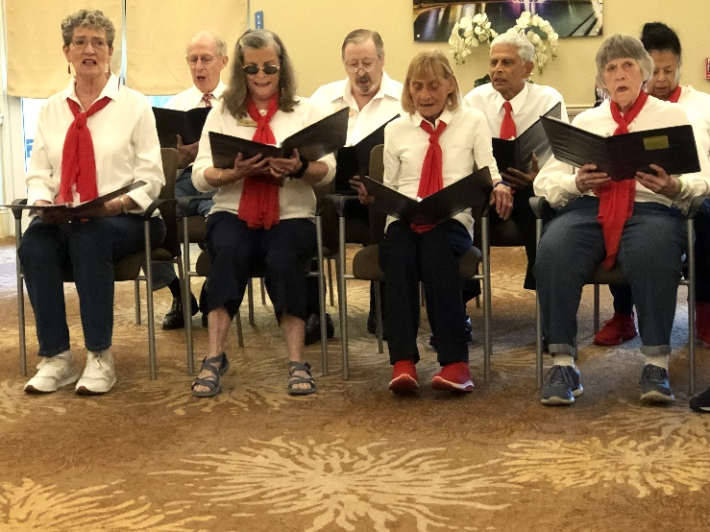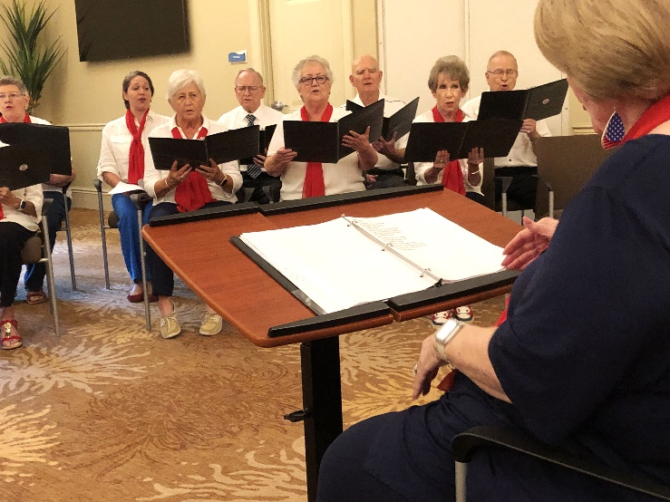

The Legacy Pointe Foodies Group
By Bill Malfitano

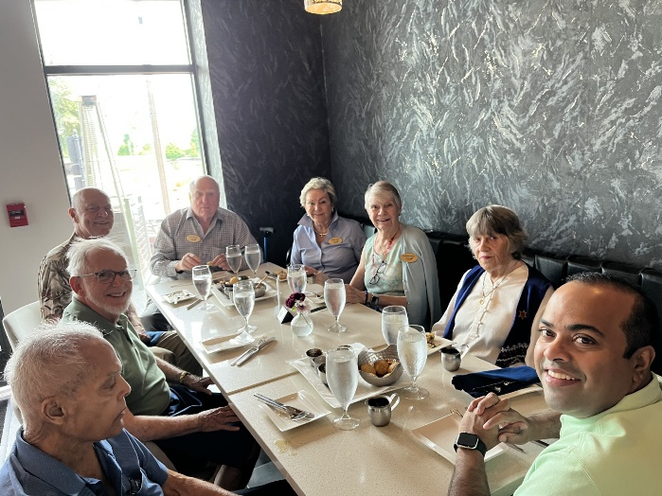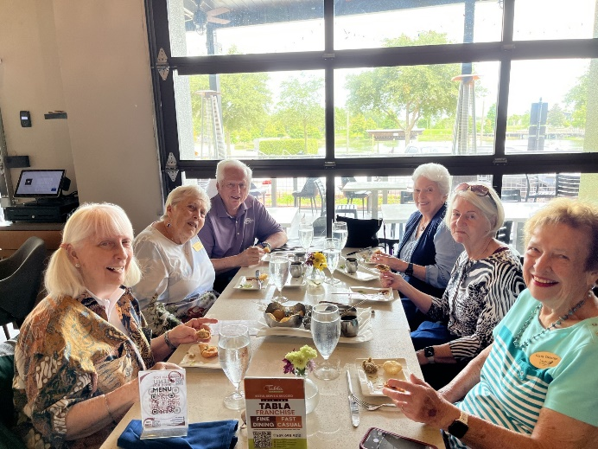

Some lucky residents of Legacy Pointe were treated to a culinary experience on Saturday June 22, 2024 at Tabla’s Restaurant in Oviedo. The 32 L.P. residents were part of a Quarterly Foodie Lunch outing. Tabla’s serves Indian Cuisine.
The entire menu, dining experiences, and special guests was orchestrated by Sarah George Hansard, the daughter of L.P. resident, George Cheryan. Sarah not only arranged a dining experience to be remembered, which included explanations of each course as well as the herbs and spices used.
As a special addition to the food there were several guests invited. They were Mrs. Salmah Hack who is a contributing author to the Great American Recipe Book. The second guest was Mrs. Vidisha Bajpai from New Delhi. She shared her passion as An artist in Indian Folk Art. She showcased some of her work.

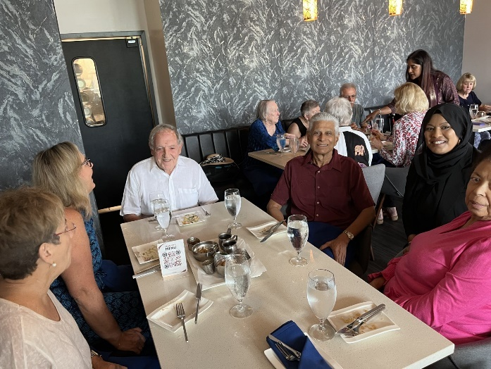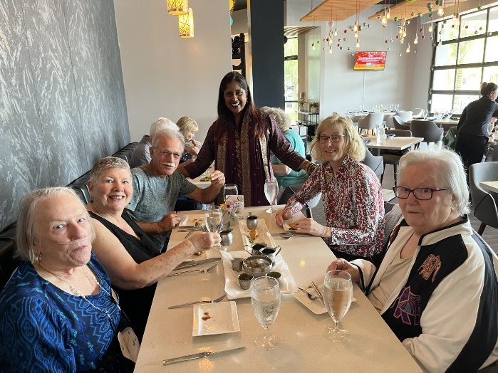

Movie Committee Report July 2024

July "Sundays at the Movies" in the Auditorium at 6 pm:
- July 7th - "Mama Mia" hosted by Bill Weise or his designee;
- July 14th - "Big Fat Greek Wedding" hosted by Bill Malfitano;
- July 21st - "Boys in the Boat" hosted by Bill Weise or his designee;
- July 28th - "Top Gun" hosted by Bill Weise or his designee;
Please note that we have also scheduled a showing on August 4th for "Date Night" that Bill Weise also owns.

Movie Updates: I will attempt to summarize the consensus of the interested residents present at the meeting recently held, from my notes and my memory, so please notify me of any glaring errors so we can accurately proceed forward in our collective goal to entertain Residents.

We are going to collect lists of available movies owned by Residents that are willing to allow the Movie Committee Members to play their movies on Sunday Nights. Movies borrowed from residents will be picked up and returned after showing by the Host/Committee Member to the residents. Clare Pollard agreed to be the one to receive emails of listings from residents and her email is: clarepollard@yahoo.com

Linda Parsons-Rude obtained the list of possible movies we can get from the Seminole County Public Library and, in fact, has the next movie, "Rear Window" with Jimmy Stewart, that she picked up from the Library.

Going forward those interested in "Sundays at the Movies" Presentations will meet on the third (3rd) Tuesday of every month for approximately one (1) hour in the Card Room to make suggestions/selections for Movies to show in the following month. The one making the nomination should attempt to verify in advance that the movie is available free of charge and that it should not exceed 1.5 to 2 hours in length max. This would allow residents to start home approximately at 8 pm assuming we start promptly at 6 pm. There could be exceptions for special showings but normally the movie should run no longer than two (2) hours.

Movie Meeting dates for 2024 are accordingly:
- July 16th @1:30 pm in the Card Room;
- August 20th @1:30 pm in the Card Room;
- September 17th @1:30 pm in the Card Room;
- October 15th @1:30 pm in the Card Room;
- November 19th @1:30 pm in the Card Room;
- December 17th @1:30 pm in the Card Room.
Please make Residents aware of the Movies and meetings.

Bill Fernandez 2100 Hestia Loop, Apt. 154, Oviedo, FL 32765-94

More Springtime visitors by Maureen Reed



Barely Visible in the center is an Eastern Tiger Swallowtail Butterfly

A Pet Story – Hope Part 2 Mary Catherine Ricks writes about her cat HOPE
Graham and I were camping at Marathon in the FL keys. As you may remember from the last newsletter our traveling cat of 14 years finally decided to communicate with me. On her final day, I was cleaning where she had been sick during the night. She was watching me with her beautiful Cleopatra lined green eyes.

All of a sudden, I heard her say, "today is the day mom and you know what to do." She had been sick for several weeks and the vet had explained that it might be food allergies or something more serious, so I knew just what Hope meant.

My reaction was that I definitely understood her, so I mentally asked why she had chosen that moment to communicate with me. Her answer was that she knew that I would understand that it was real. She went on to convey that her time on earth was over because we had things in our future to do that would be hard on her, however she would be returning so not to bother looking for another cat. Then she gave me her greatest gift. She said, "I loved my name Hope. It is an acronym for Heart Opening Peaceful Energy." That took me totally by surprise because that was a perfect description of her. During all our travels she made lots of our RVing (recreational vehicle) friends happy, even those that typically preferred dogs!

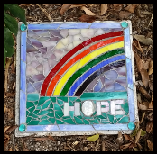

Graham was told about what had happened, and he understood. I called a friend that lived in Marathon, and she told me to tell the vet that we had a local place to bury her, in Vesta’s beautiful orchid garden. I called the vet, and a quick appointment was made within the hour. From the vet we went directly to the orchid garden. Bless Vesta’s heart, a small place was prepared in the ground surrounded by orchids. She and her husband had 4 chairs there and a small table with a Tibetan bowl. She felt our sadness and was prepared to say a few words about our beloved cat. Then she played her bowl, and we released her to the rainbow in the sky.
The sun is reflecting through a mirror
bevel and casting a rainbow on Hope.

Vesta is such a treasure. Not only was she our good friend but also our dance instructor and a stained-glass artist. She wanted to do a picture of Hope in glass as a grave cover which is what she had done for her pets. Because of all the stripes on Hope, we decided a rainbow was a perfect choice!
The animal communication teacher taught that animals generally respond to pictures better than words and that all beings communicate even if it appears that it is only with each other. As indicated by this story they do it in their own time, but it helps to open the door by being aware that it is possible.
Did Hope really to come back? You’ll find out in the August newsletter.
Social, Physical, and Nutritional aspects of ‘senior living’.

Each month, here are articles about social fitness, physical fitness, and nutritional fitness. They are for your interest. We do not make any claims or recommendations.
Social Fitness: Are You a SuperAger?
The term SuperAgers was created by researchers at Northwestern University, who define it as “adults over age 80 who have the memory capacity of individuals who are at least three decades younger.” Northwestern University is one of just a handful of institutions in the country that have SuperAging research programs.

“SuperAger is not just someone who’s long-lived. It’s also someone who’s maintained a fairly high level of physical, cognitive, psychological and social well-being.” according to Jennifer Ailshire, an associate professor of gerontology at the University of Southern California…
Check out the full article from the HUFF Post to see if you are a “SuperAger”
https://www.huffpost.com/entry/superager-aging-well-tips-ano_l_667c7c16e4b07cb66c6cae94
(hold the control key and click on the link or copy it and paste it into your browser).
Physical Fitness

Man, 110, still drives his car every day, lives on his own. He stays physically active. Read his story at the link below
https://www.today.com/health/men-s-health/110-year-old-man-drives-car-rcna148538
(hold the control key and click on the link or copy it and paste it into your browser).
Nutritional Fitness :

What is the 80/20 rule for senior nutrition. Check outnthe link below to find out this and many other insights for staying healthy.

https://nypost.com/2024/02/28/lifestyle/9-ways-to-live-to-100-and-have-fun-while-doing-it-according-to-longevity-experts/

(hold the control key and click on the link or copy it and paste it into your browser).

DO YOU NEED TO GET OUT AND DO SOMETHING?

Do you want to take a little trip for a change of scenery then check out the link below where you will find 25 suggestions on short trips from Oviedo.
https://www.orlandoweekly.com/orlando/25-easy-weekend-road-trips-from-orlando-everyone-should-do-at-least-once/Slideshow/35988297/35989533
(hold the control key and click on the link or copy it and paste it into your browser).

IF YOU DO NOT WANT TO GO OUT, CHECK OUT KRISTINA FERRY IN HER WEEKLY POSTINGS BELOW ARE OPPORTUNITIES IF YOU STAY IN - JOIN a CLUB

Check out your ‘Community Info (formerly Touch Town) on your phone. There are over a dozen clubs here at Legacy Pointe that would love to have you join. Also, in the Card Room there are many activities each day some starting at 7 AM

Here are just a few available The Legacy Pointe Book Club, Garden Club, Chess Club, and many others. Check Touch Town for dates and times of many others

The Legacy Pointe Book Club

The Legacy Pointe Book Club meets the third Tuesday of the month at 3 PM in the Card Room

Our Book for July is called The Story Keeper” by Lisa Wingate
The Book Club will meet on Tuesday July 16th at 3 pm in the Card Room.


Wingate is, quite simply, a master storyteller. Her story-within-a-story, penned with a fine, expressive style, will captivate writers and nonwriters alike. -- Booklist
Successful New York editor, Jen Gibbs, is at the top of her game with her new position at Vida House Publishing -- until a mysterious manuscript from an old slush pile appears on her desk. Turning the pages, Jen finds herself drawn into the life of Sarra, a mixed-race Melungeon girl trapped by dangerous men in the turn of the century Appalachia. A risky hunch may lead to The Story Keeper's hidden origins and its unknown author, but when the trail turns toward the heart of the Blue Ridge Mountains, a place Jen thought she'd left behind forever, the price of a blockbuster next book deal may be higher than she's willing to pay.

Our Book for August is called Handling Sin by Michael Malone


On the Ides of March, our hero, Raleigh Whittier Hayes (forgetful husband, baffled father, prosperous insurance agent, and leading citizen of Thermopylae, North Carolina), learns that his father has discharged himself from the hospital, taken all his money out of the bank and, with a young Black female mental patient, vanished in a yellow Cadillac convertible. Left behind is a mysterious list of seven outrageous tasks that Raleigh must perform in order to rescue his father and his inheritance.
And so, Raleigh and fat Mingo Sheffield (his irrepressibly loyal friend) set off on an uproarious contemporary treasure hunt through a landscape of unforgettable characters, falling into adventures worthy of Tom Jones and Huck Finn. A moving parable of human love and redemption, Handling Sin is Michael Malone’s comic masterpiece.

Qigong Tidbits by Mary Catherine Ricks

Many of you know that “Qi” or “Chi” is the Chinese word for energy.

“Everything is energy and that is all there is to it. Match the frequency of the reality that you want, and you cannot help but get that reality. It can be no other way. This is not philosophy. This is physics.” Those statements were made by Albert Einstein, who was born in Germany in 1879 and died in America in1955.

Einstein also stated, “Matter is Energy. . . Energy is Light . . . We are all Light Beings.” This energy travels through pathways, known in Chinese medicine as meridians, all over the body. You might think of meridians similar to fiber optic cables which as you know carry light, which is energy. These pathways have been scientifically documented as far back as 1960 by a Korean scientist, Kim Bonghan. It has also been discovered that these channels carry not only energy but also a fluid that lubricates the joints, eyes, skin, and heart valves.

So, what happens when the meridians get blocked? The simple answer is poor health. And where do these blockages come from? The simple answer to that is, what we breathe, eat, think, and feel can cause these blockages and they will differ from one person to another. The good news is that Qigong is a method to clear the blockages. Isn’t that amazing?

Here at Legacy Pointe, some of us are now practicing Qigong. In other words, we are moving energy and light, to improve our health, as understood by the Chinese master of years ago.

SPACE LAUNCHES AT KENNEDY SPACE CENTER FOR July 2024



Photo by Joyce Swing

For list of all launches, check this website suggested by John Boldt
https://nextspaceflight.com/launches/

SURFING THE INTERNET
You could spend your whole day just sitting and surfing. If you do this your entire body will fall apart from lack of exercise. So, our newsletter is asking its readers who spend just a few minutes a day surfing to send along some links to articles that may be interesting or funny or extremely important. Send links to Frank Russo at frankrusso2012@gmail.com

Richard Van Dyk found this article on the web.

Have we ever been scammed or know someone who has been scammed. The FCC is checking out AI scams. Read the article below.

FCC names its first-ever AI scammer in threat alert

https://www.foxnews.com/tech/fcc-names-its-first-ever-ai-scammer-threat-alert

Having Some Fun - found on the Internet by Vicki Tindall

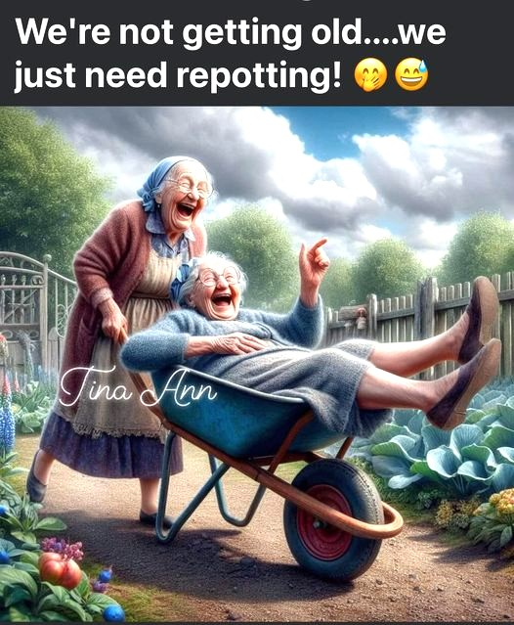

Feedback? Stories? Photos?
Send to Frank Russo at frankrusso2012@gmail.com

REMEMBER sign up for the LP Residents Forum: https://lpresidentsonline.org/smf You can easily set up your login and password. The Forum is a place for you and your neighbors to come together . . . To create a knowledge base . . . To go beyond a community to becoming a family. We hope to see you online soon. If you need help, contact by email Jonathan or Ina.

"And in case you missed any issues, click the following link to access the complete Newsletter Archive:" ..
LP Residents Forum - Residents Newsletters (lpresidentsonline.org)
Email Jonathan at 47ipsd@gmail.com or Ina at utgrad@attglobal.net.

New Forum Feature

Please check out In Memoriam, the latest Category on your Legacy Pointe Forum.
It is a place where we can express our love and memories of cherished members of our Legacy Pointe Family who are no longer with us. A place to celebrate their lives and assure they will not be forgotten. And a place to draw comfort from our shared memories. Please feel free to share pictures, stories, memories, tributes, and obituaries.
To Create a memorial, click New Topic and type the person's name. To add your sentiments to an existing memorial, click Reply.
If you have any questions or need help using the Forum please contact Jonathan or Ina, your forum Administrators.

Jonathan and Ina

Our Day Ends

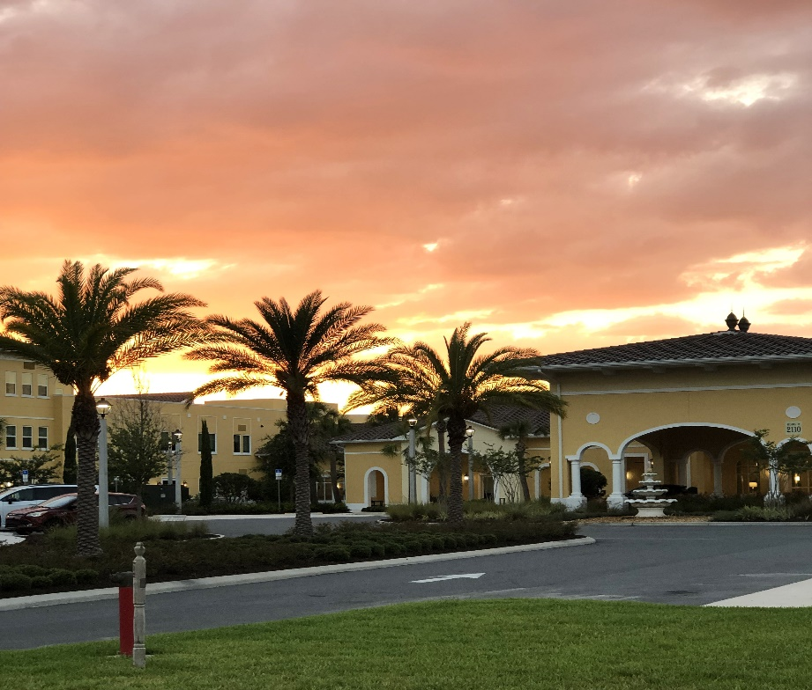
Photo by Marsha Call

